**Paper - 1: Learning a River Network Extractor Using an Adaptive Loss Function**

**DATA GENERATION:**

Data used to train models is randomly generated synthetic data which is basically white lines on black background



**TRAINING:**

Random blur effects, distortions, contrast shifts, noise, brightness shifts are applied to the synthetic data and the data is trained against the base image until the model is accurate enough to identify the intersections and differentiate between seas and rivers

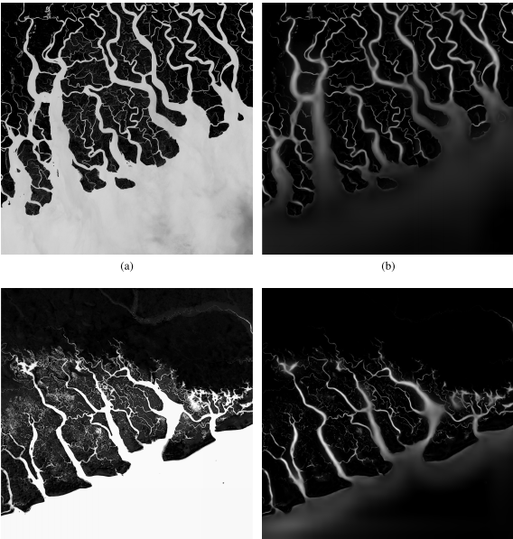

**Detection:**

After training the model on synthetic data the algorithm is applied to real natural images to get the river outlines. The outcome is extremely resistant to noise because it’s already trained with noise added to the synthetic data.

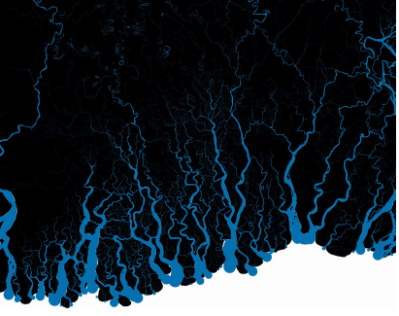

**PROBLEMS TO OVERCOME:**

Since the major part of the image is black pixels and the training is done per pixel the algorithm assumes that black is dominant but to contract that an adaptive loss function is used to calculate the pixels with the highest loss function and pooling images based on loss function rather than average and taking the pool size (8x8).